H1 – [Product Name]
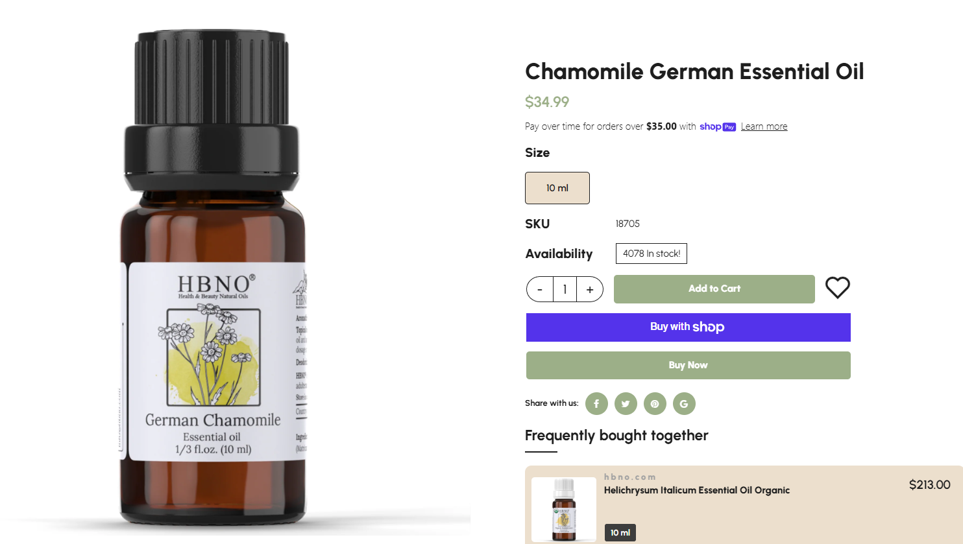
Note: Keep this layout

Image
- Prize
- Size
- SKU
- Availability

Call to Action Buttons
Add to Cart
Buy with Shop Pay
Buy Now

About the Product
For example:
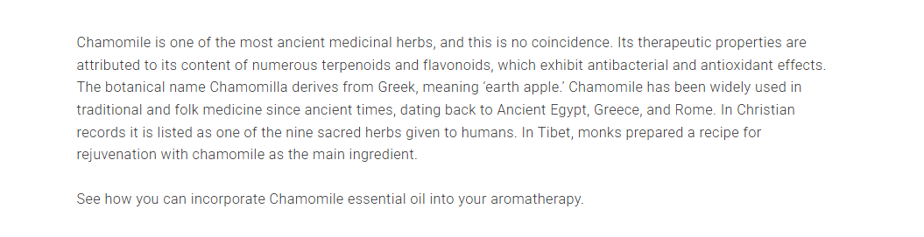
https://ecomaat.eu/chamomile-essential-oil-discover-its-properties-and-benefits/

Key Benefits for You
For Example:

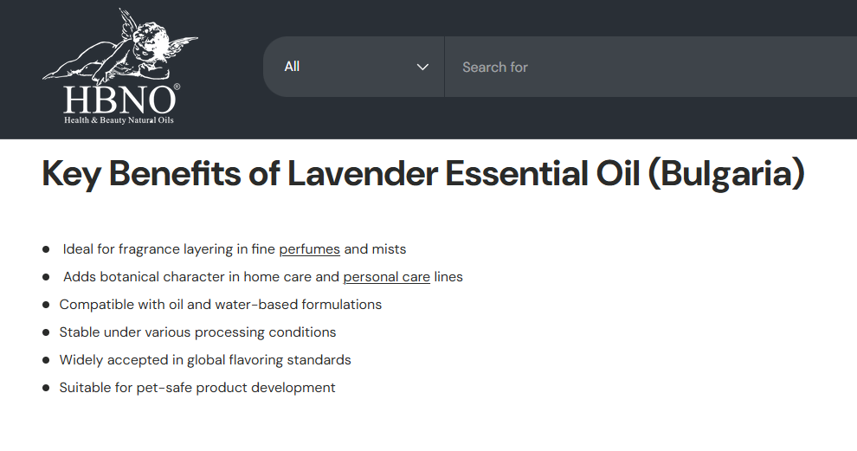

Perfect Pairings
For Example:
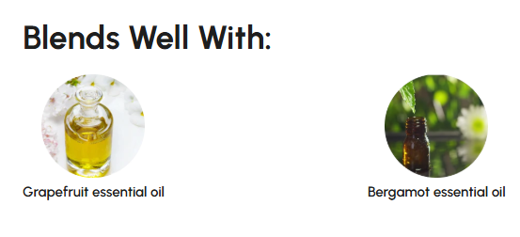

Product Details
For Example:
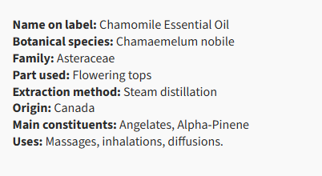
https://www.cliniquelafontaine.com/en/products/chamomile-essential-oil?variant=42316652314793

Botanical Name:
Plant Family:
Plant Part Used:
Extraction Method:
Aroma:
Country of Origin:

How to Use
For Example:

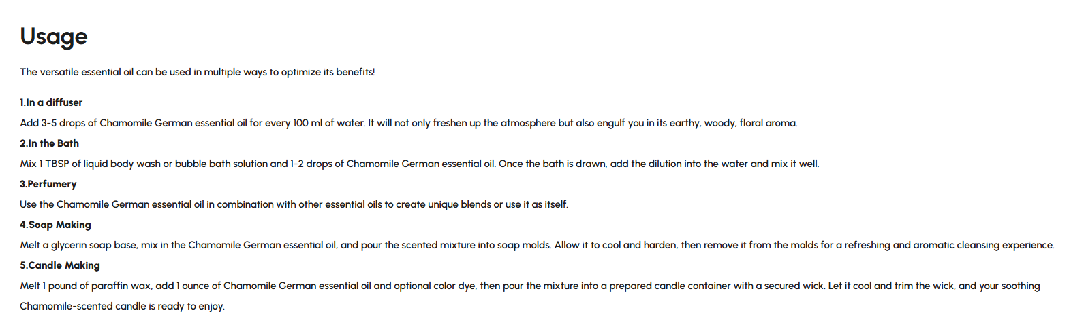
For Everyday Use
Aromatherapy
Topical Application
DIY & Home Care
Perfumery

Safety & Recommendations
For Example:
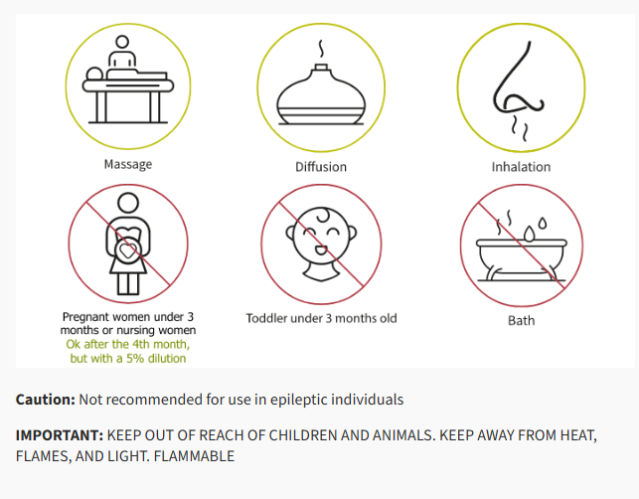

Why Choose HBNO®
Reassure buyers with trust signals. For Example:
- Responsibly sourced & ethically produced
- Bottled in UV-protective amber glass
- Lab-tested for purity and potency
- Cruelty-free and vegan

You May Also Like
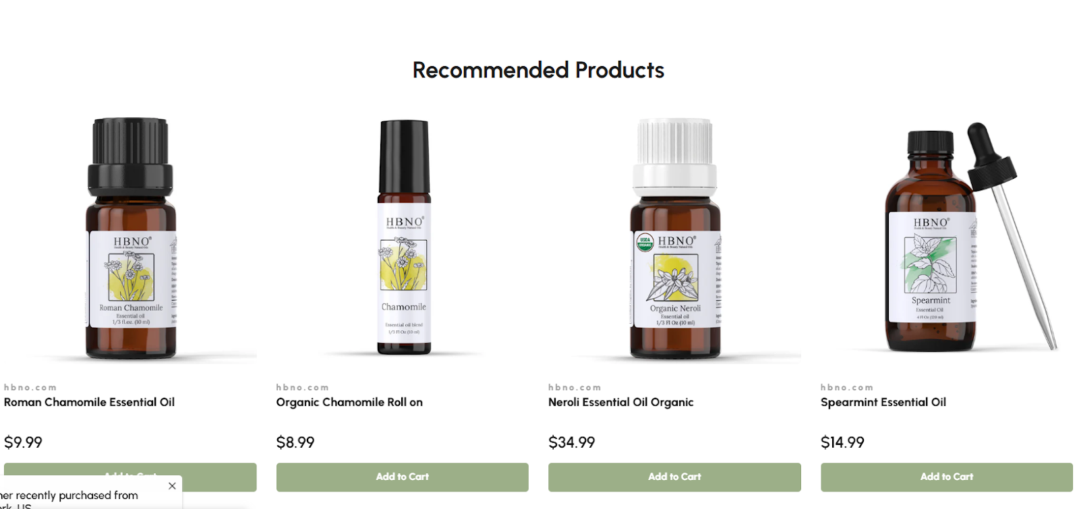

Bottom CTA Section

Ready to Experience [Product Name]?
Add to Cart Buy Now

FAQs
For Example:
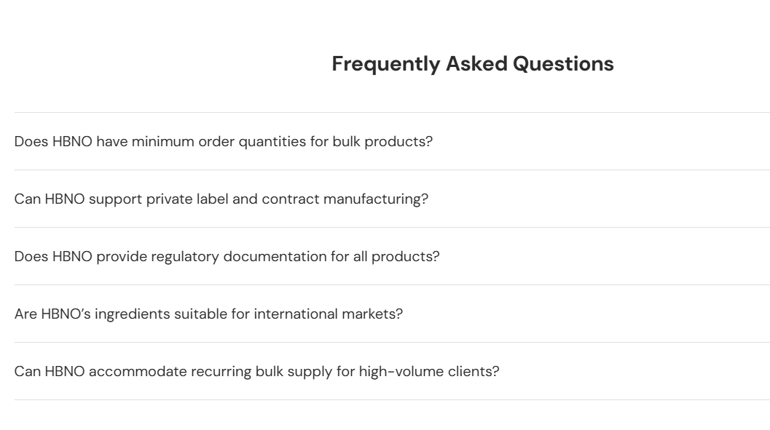
This is just an example, this FAQs is for Bulk.

Reviews
For Example:
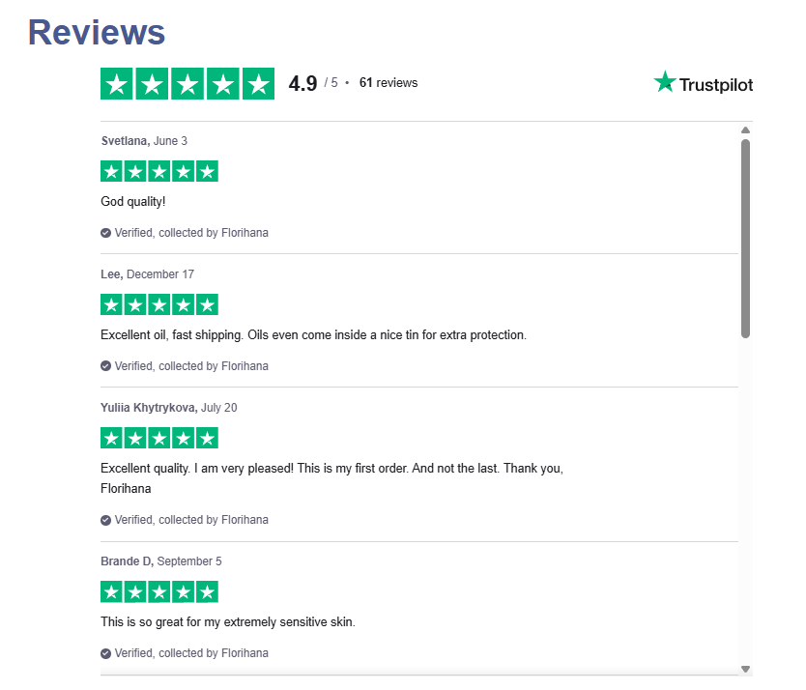
https://www.florihana.com/en/essential-oils/139-german-chamomile-organic.html?srsltid=AfmBOooOyIvfBxv7Dw4WexI4Ok37M3ZtRwjpv7mHxH_keO-mGDHBzUGS

